ANALYSIS
REPORT

Rockfeller, John_Proposal001

6/10/2026

Table of Contents

Your area
Area overview
Demographics
Points of interest
Demographics
Population
Employment
Household
Housing
Points of interest
Pilates Studios
Blink Fitness
Data sources

Your area

1

Area overview

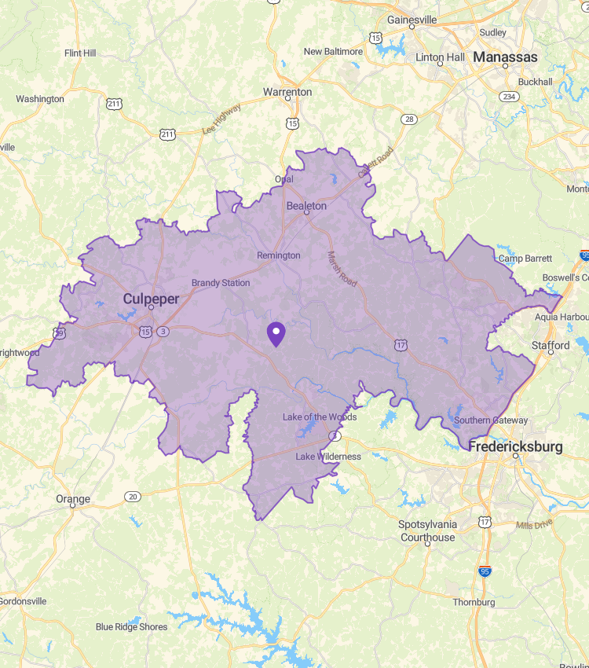
 | Location: | Rockfeller, John_Proposal001

Demographics
 | Area | USA
Number of inhabitants | 132 852 | 338 079 058
Number of households | 45 415 | 130 499 663
Average age | 38 | 39
Median household income | $111 027 | $80 164
Most represented class of worker | Private for-profit wage and salary workers | Private for-profit wage and salary workers

Points of Interest

Pilates Studios | 6
Blink Fitness | 0

Demographics

2

Population

Population | 132 852
Average income per person | 46 956
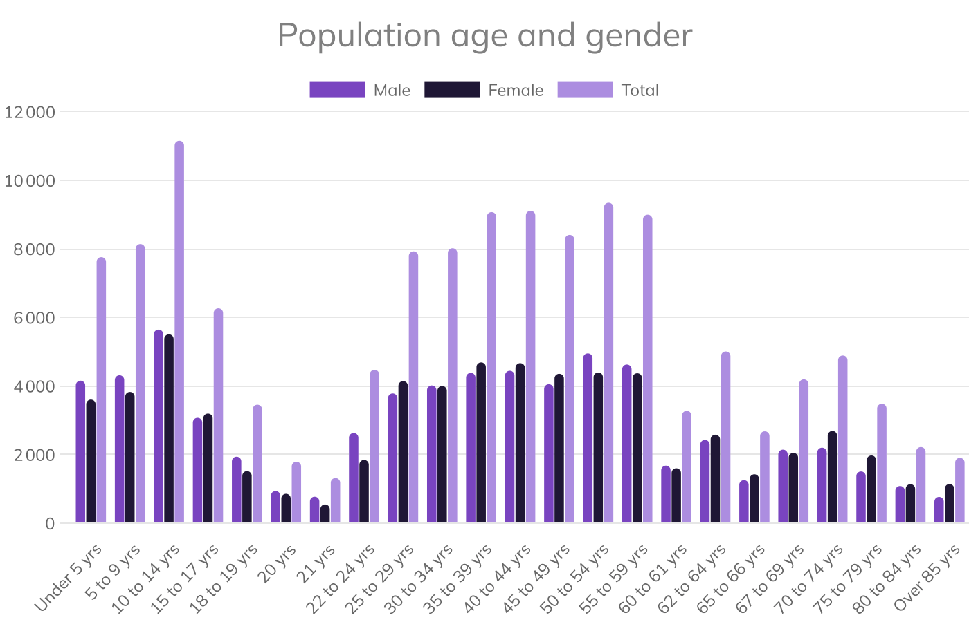
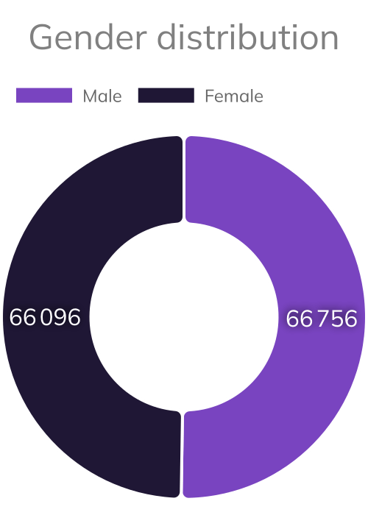

 |   Female |   Male | Total | 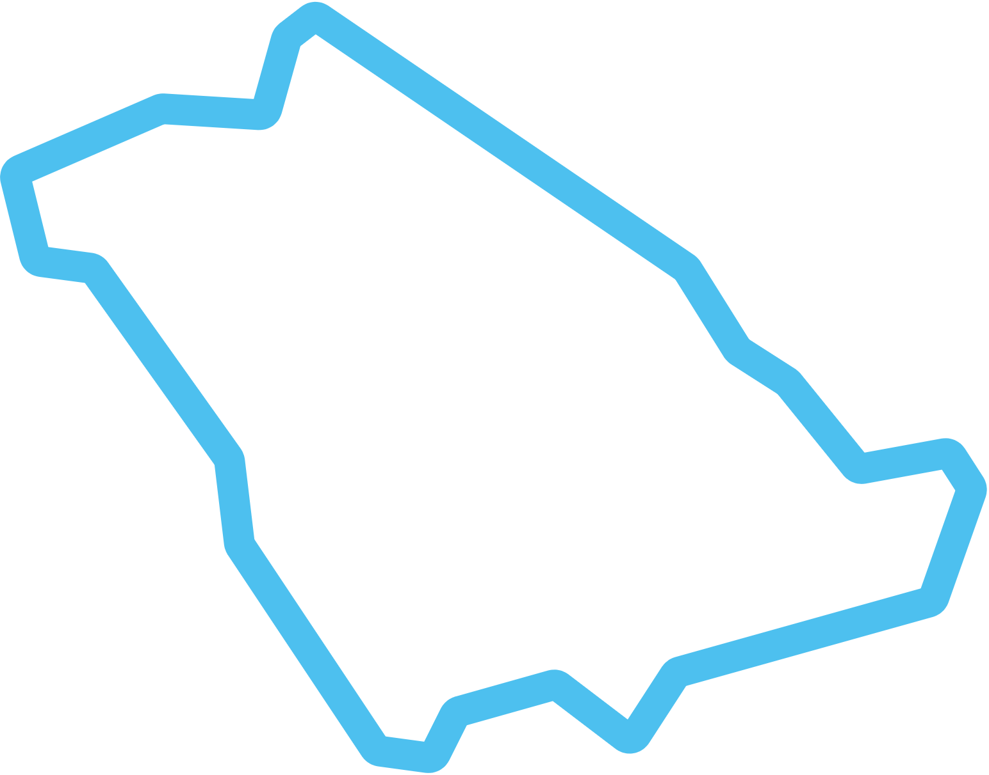  % Area | % USA
Gender
Total | 66 096 | 66 756 | 132 852
Age group
Under 5 yrs | 4,154 | 3,603 | 7,757 | 5.84 % | 5.58 %
5 to 9 yrs | 4,312 | 3,826 | 8,138 | 6.13 % | 5.98 %
10 to 14 yrs | 5,644 | 5,506 | 11,150 | 8.39 % | 6.40 %
15 to 17 yrs | 3,072 | 3,195 | 6,266 | 4.72 % | 3.93 %
18 to 19 yrs | 1,937 | 1,517 | 3,453 | 2.60 % | 2.63 %
20 yrs | 936 | 855 | 1,791 | 1.35 % | 1.32 %
21 yrs | 770 | 545 | 1,315 | 0.99 % | 1.31 %
22 to 24 yrs | 2,629 | 1,843 | 4,472 | 3.37 % | 3.88 %
25 to 29 yrs | 3,782 | 4,143 | 7,925 | 5.97 % | 6.69 %
30 to 34 yrs | 4,016 | 4,000 | 8,016 | 6.03 % | 6.99 %
35 to 39 yrs | 4,382 | 4,688 | 9,070 | 6.83 % | 6.72 %
40 to 44 yrs | 4,443 | 4,666 | 9,109 | 6.86 % | 6.48 %
45 to 49 yrs | 4,051 | 4,354 | 8,405 | 6.33 % | 5.97 %
50 to 54 yrs | 4,950 | 4,393 | 9,343 | 7.03 % | 6.20 %
55 to 59 yrs | 4,626 | 4,371 | 8,996 | 6.77 % | 6.25 %
60 to 61 yrs | 1,676 | 1,599 | 3,275 | 2.47 % | 2.63 %
62 to 64 yrs | 2,426 | 2,580 | 5,006 | 3.77 % | 3.78 %
65 to 66 yrs | 1,254 | 1,424 | 2,678 | 2.02 % | 2.36 %
67 to 69 yrs | 2,143 | 2,050 | 4,193 | 3.16 % | 3.24 %
70 to 74 yrs | 2,200 | 2,689 | 4,889 | 3.68 % | 4.60 %
75 to 79 yrs | 1,507 | 1,974 | 3,481 | 2.62 % | 3.15 %
80 to 84 yrs | 1,083 | 1,136 | 2,219 | 1.67 % | 1.99 %
Over 85 yrs | 764 | 1,140 | 1,904 | 1.43 % | 1.93 %

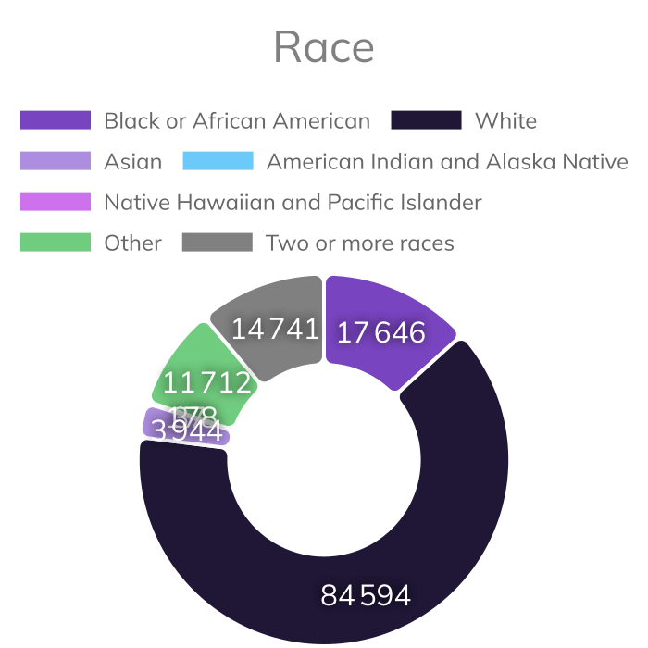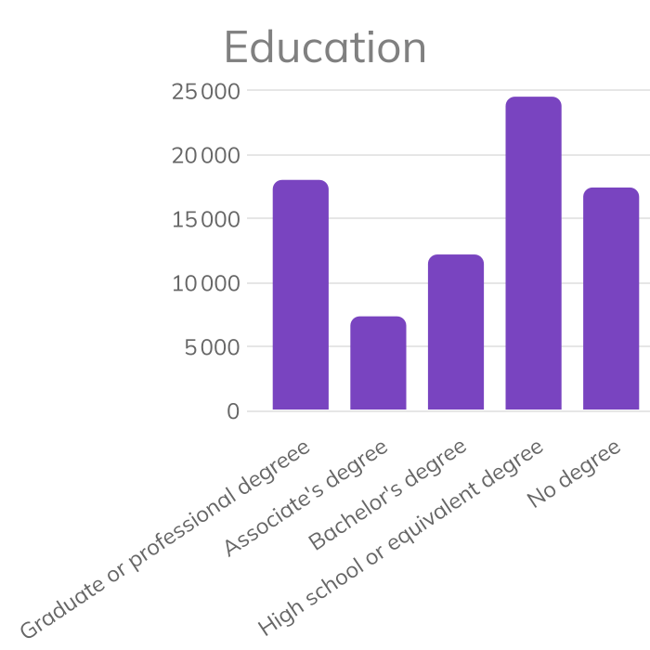

 |  |  | Total | % Area | % Usa
Race
Black or African American |  |  | 17,646 | 13.28 % | 12.16 %
White |  |  | 84,594 | 63.68 % | 60.63 %
Asian |  |  | 3,944 | 2.97 % | 5.90 %
American Indian and Alaska Native |  |  | 178 | 0.13 % | 0.92 %
Native Hawaiian and Pacific Islander |  |  | 37 | 0.03 % | 0.19 %
Other |  |  | 11,712 | 8.82 % | 7.35 %
Two or more races |  |  | 14,741 | 11.10 % | 12.86 %
Education
Graduate or professional degreee |  |  | 18,021 | 22.66 % | 24.13 %
Associate's degree |  |  | 7,358 | 9.25 % | 9.87 %
Bachelor's degree |  |  | 12,192 | 15.33 % | 15.67 %
High school or equivalent degree |  |  | 24,527 | 30.84 % | 29.10 %
No degree |  |  | 17,429 | 21.92 % | 21.23 %

Employment
Labour force | 67 731
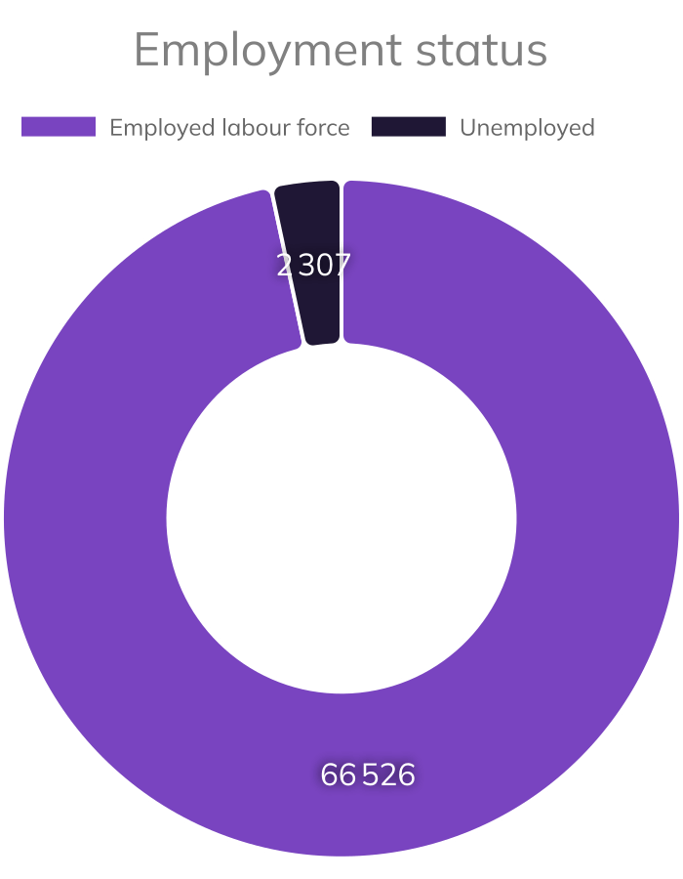
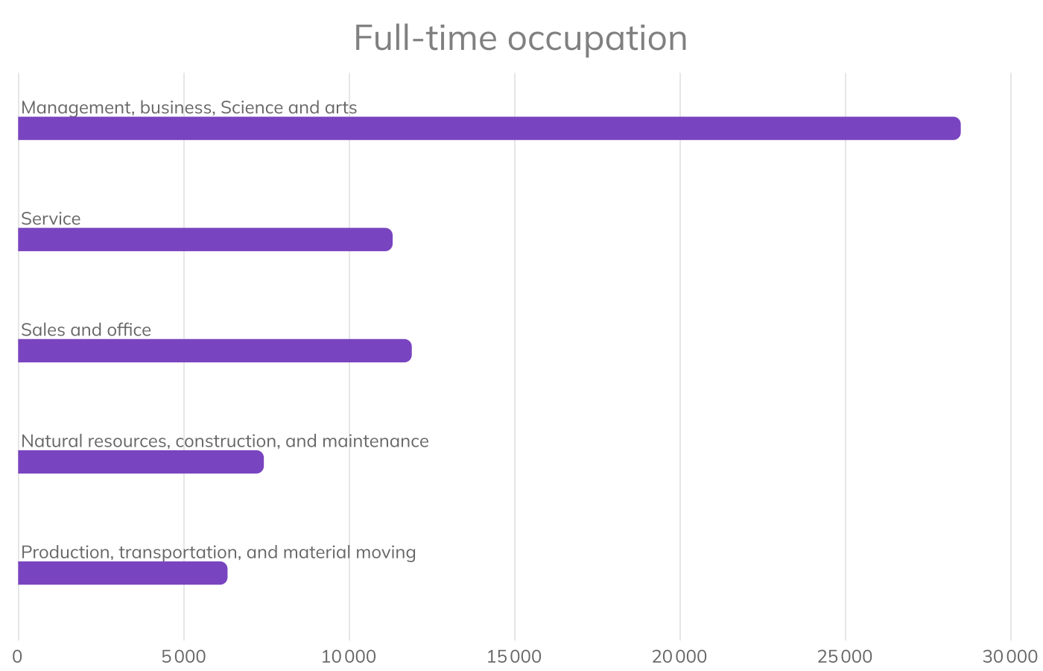
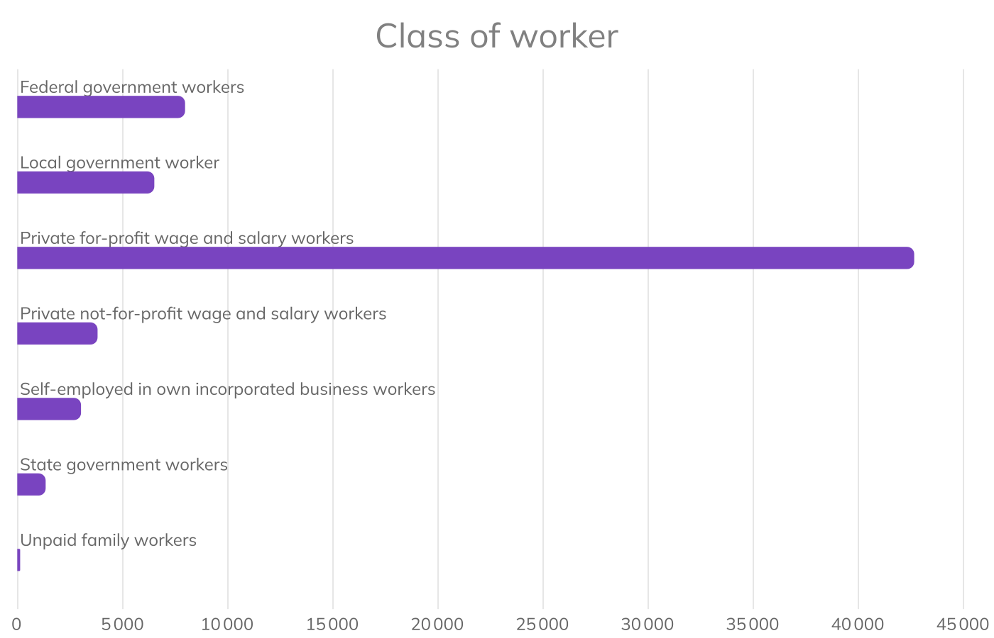
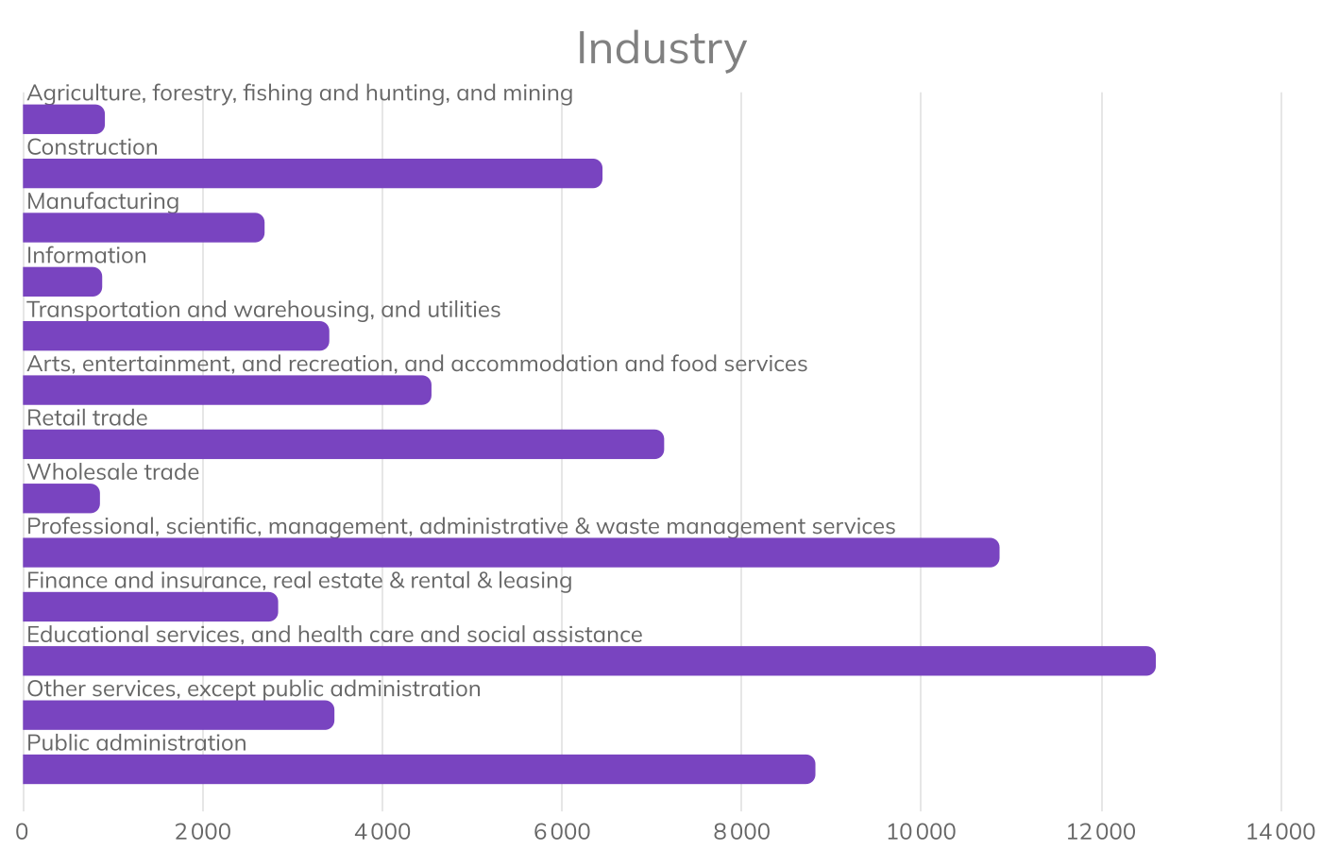

 | Total | % Area | % USA
Employment status
Employed labour force | 66,526 | 96.65 % | 94.77 %
Unemployed | 2,307 | 3.35 % | 5.23 %
Full-time occupation
Management, business, Science and arts | 28,481 | 43.53 % | 42.58 %
Service | 11,312 | 17.29 % | 16.36 %
Sales and office | 11,890 | 18.17 % | 19.70 %
Natural resources, construction, and maintenance | 7,419 | 11.34 % | 8.48 %
Production, transportation, and material moving | 6,322 | 9.66 % | 12.88 %
Class of worker
Federal government workers | 7,970 | 12.18 % | 2.71 %
Local government worker | 6,508 | 9.95 % | 7.59 %
Private for-profit wage and salary workers | 42,653 | 65.19 % | 70.42 %
Private not-for-profit wage and salary workers | 3,808 | 5.82 % | 8.81 %
Self-employed in own incorporated business workers | 3,021 | 4.62 % | 6.02 %
State government workers | 1,338 | 2.05 % | 4.27 %
Unpaid family workers | 126 | 0.19 % | 0.19 %

 | Total | % Area | % USA
Industry
Agriculture, forestry, fishing and hunting, and mining | 908 | 1.39 % | 1.56 %
Construction | 6,445 | 9.85 % | 6.92 %
Manufacturing | 2,685 | 4.10 % | 9.88 %
Information | 878 | 1.34 % | 1.86 %
Transportation and warehousing, and utilities | 3,405 | 5.20 % | 5.92 %
Arts, entertainment, and recreation, and accommodation and food services | 4,542 | 6.94 % | 8.66 %
Retail trade | 7,131 | 10.90 % | 10.84 %
Wholesale trade | 853 | 1.30 % | 2.18 %
Professional, scientific, management, administrative & waste management services | 10,863 | 16.60 % | 12.57 %
Finance and insurance, real estate & rental & leasing | 2,836 | 4.33 % | 6.68 %
Educational services, and health care and social assistance | 12,602 | 19.26 % | 23.49 %
Other services, except public administration | 3,462 | 5.29 % | 4.72 %
Public administration | 8,814 | 13.47 % | 4.75 %

Households
Number of households | 45 415
Average family size | 3
Median household income | $ 111 027

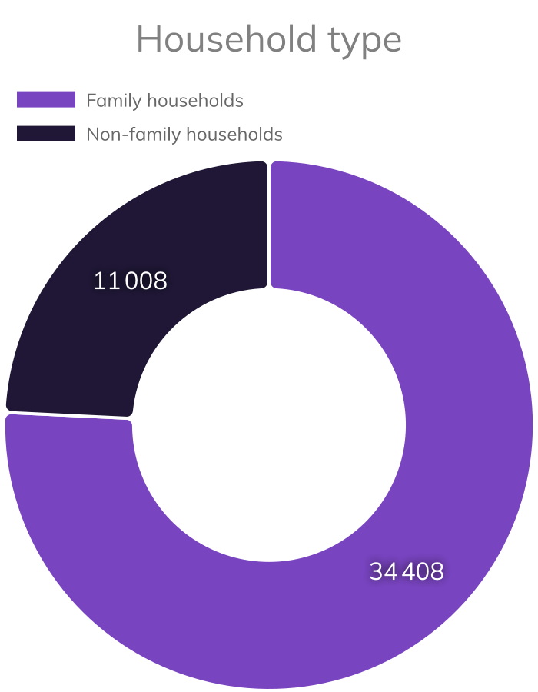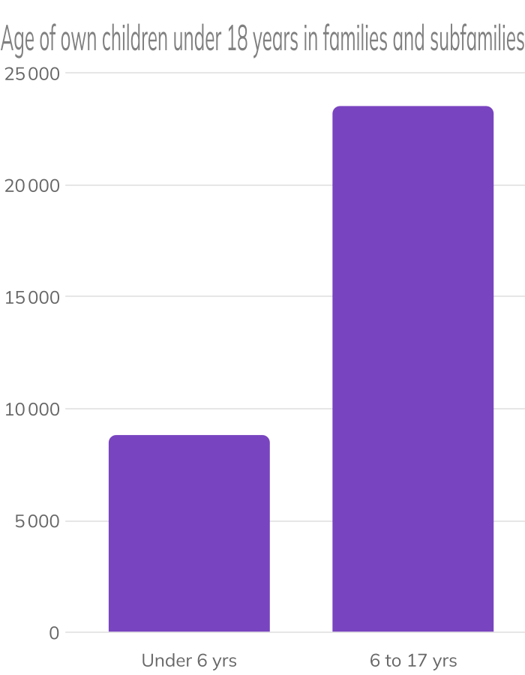
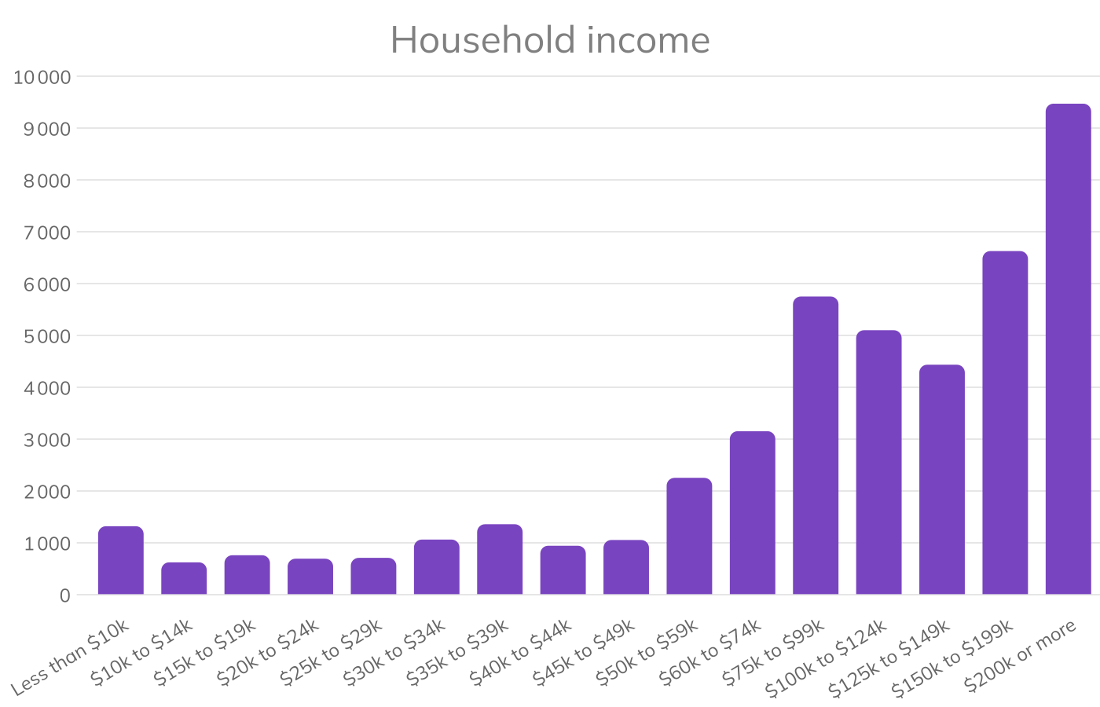

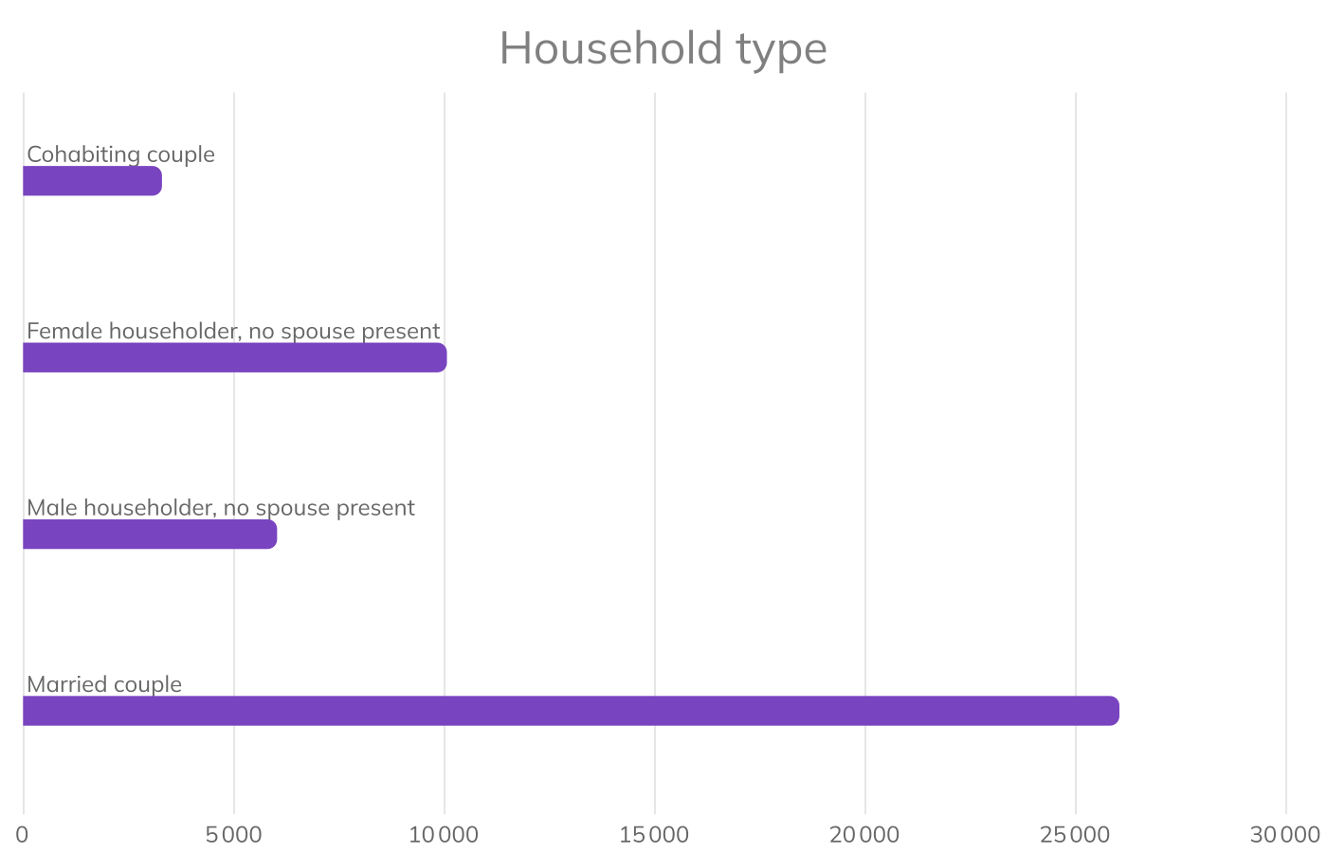

 | Total | % Area | % USA
Household type
Family households | 34,408 | 75.76 % | 64.21 %
Non-family households | 11,008 | 24.24 % | 35.79 %
Age of own children under 18 years in families and subfamilies
Under 6 yrs | 8,823 | 27.27 % | 31.10 %
6 to 17 yrs | 23,531 | 72.73 % | 68.90 %
Household income
Less than $10k | 1,326 | 2.92 % | 5.10 %
$10k to $14k | 629 | 1.38 % | 3.48 %
$15k to $19k | 766 | 1.69 % | 3.05 %
$20k to $24k | 699 | 1.54 % | 3.33 %
$25k to $29k | 715 | 1.57 % | 3.28 %
$30k to $34k | 1,068 | 2.35 % | 3.40 %
$35k to $39k | 1,364 | 3.00 % | 3.38 %
$40k to $44k | 949 | 2.09 % | 3.44 %
$45k to $49k | 1,060 | 2.33 % | 3.33 %
$50k to $59k | 2,259 | 4.97 % | 6.40 %
$60k to $74k | 3,159 | 6.96 % | 9.07 %
$75k to $99k | 5,758 | 12.68 % | 12.56 %
$100k to $124k | 5,108 | 11.25 % | 10.04 %
$125k to $149k | 4,442 | 9.78 % | 7.37 %
$150k to $199k | 6,635 | 14.61 % | 9.52 %
$200k or more | 9,479 | 20.87 % | 13.24 %
Household type
Cohabiting couple | 3,292 | 7.25 % | 7.22 %
Female householder, no spouse present | 10,061 | 22.15 % | 27.63 %
Male householder, no spouse present | 6,027 | 13.27 % | 18.35 %
Married couple | 26,035 | 57.33 % | 46.80 %

Housing
Number of dwellings | 47 694
Occupied housing | 45 415
Median housing value | $ 420 200
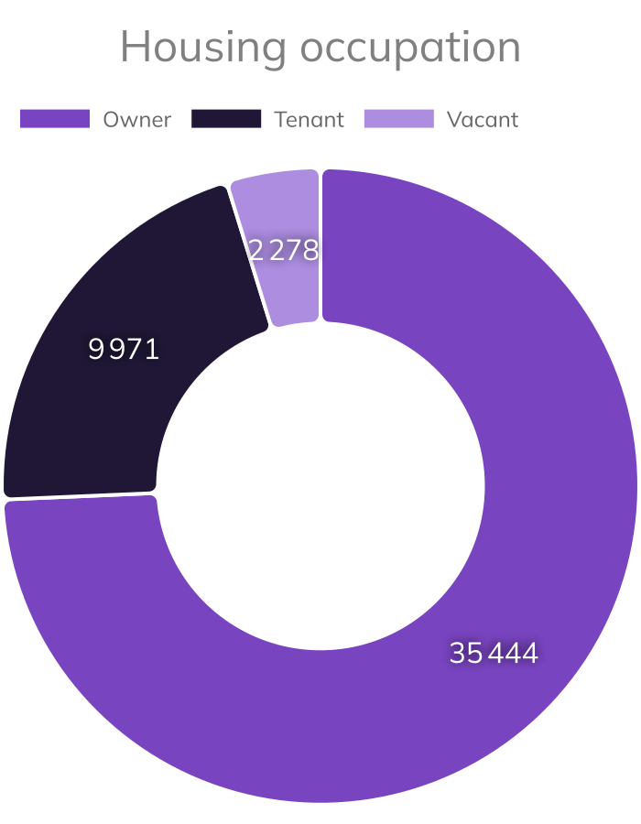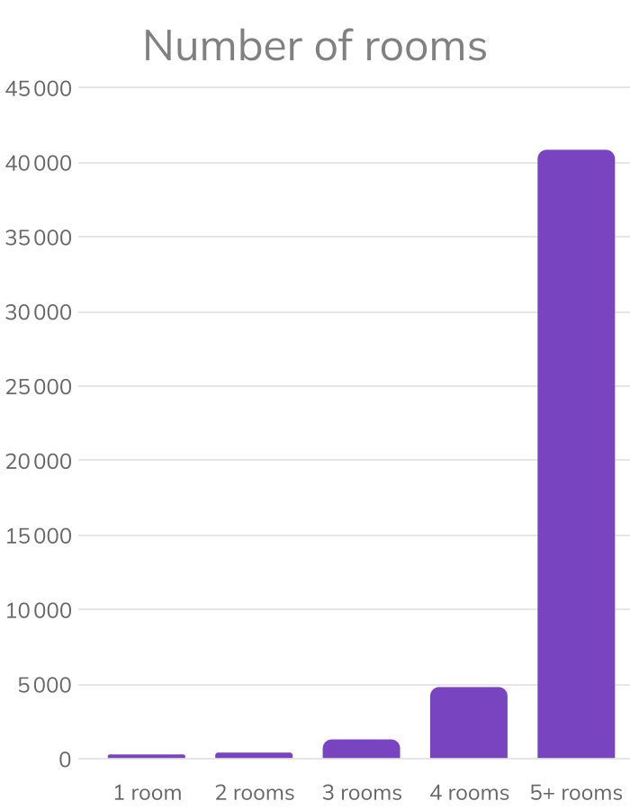
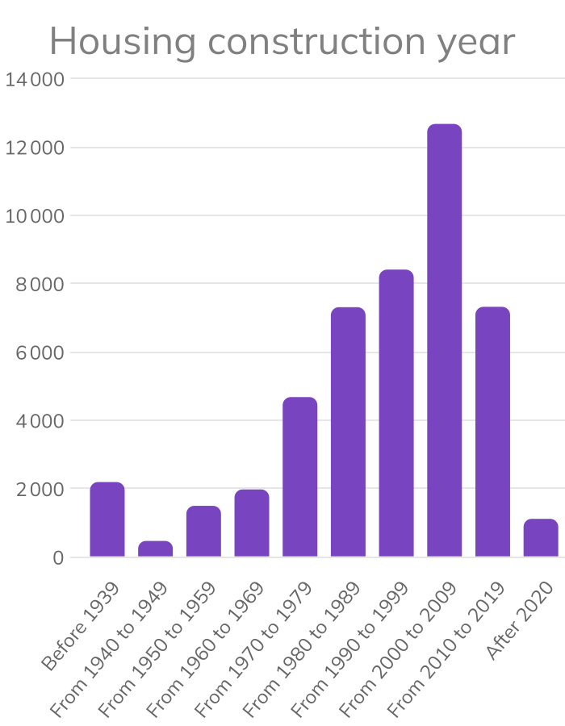
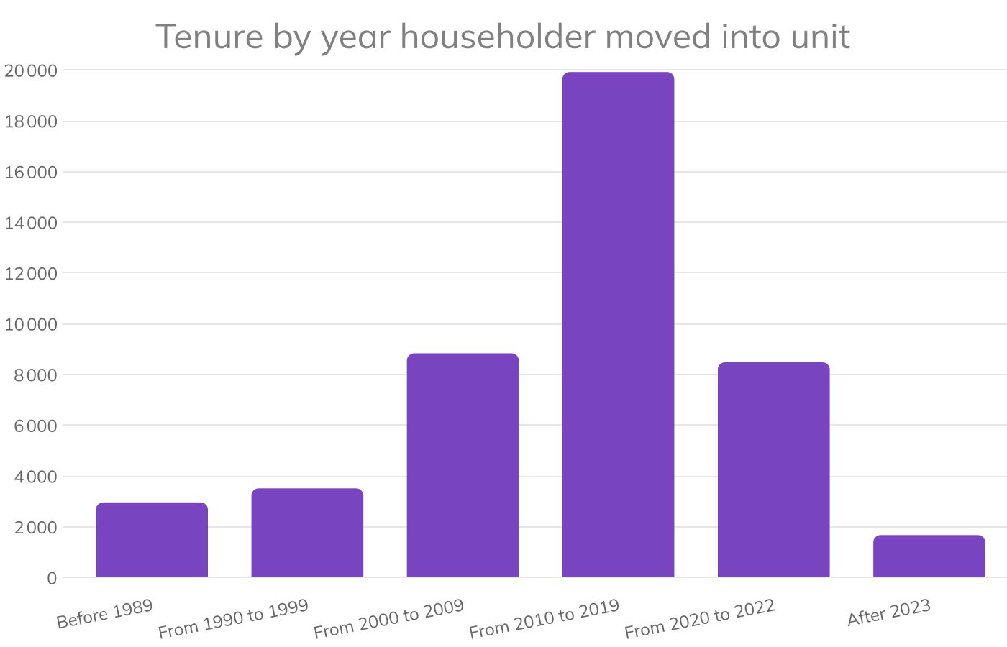

 | Total | % Area | % USA
Housing occupation
Owner | 35,444 | 74.32 % | 58.51 %
Tenant | 9,971 | 20.91 % | 31.24 %
Vacant | 2,278 | 4.78 % | 10.24 %
Number of rooms
1 room | 299 | 0.63 % | 2.58 %
2 rooms | 424 | 0.89 % | 3.25 %
3 rooms | 1,308 | 2.74 % | 9.17 %
4 rooms | 4,817 | 10.10 % | 15.98 %
5+ rooms | 40,846 | 85.64 % | 69.01 %

 | Total | % Area | % USA
Housing construction year
Before 1939 | 2,197 | 4.61 % | 11.63 %
From 1940 to 1949 | 474 | 0.99 % | 4.41 %
From 1950 to 1959 | 1,502 | 3.15 % | 9.46 %
From 1960 to 1969 | 1,982 | 4.16 % | 9.94 %
From 1970 to 1979 | 4,684 | 9.82 % | 14.25 %
From 1980 to 1989 | 7,315 | 15.34 % | 12.93 %
From 1990 to 1999 | 8,415 | 17.64 % | 12.41 %
From 2000 to 2009 | 12,678 | 26.58 % | 13.63 %
From 2010 to 2019 | 7,326 | 15.36 % | 9.37 %
After 2020 | 1,121 | 2.35 % | 1.98 %
Tenure by year householder moved into unit
Before 1989 | 2,965 | 6.53 % | 9.68 %
From 1990 to 1999 | 3,519 | 7.75 % | 9.65 %
From 2000 to 2009 | 8,841 | 19.47 % | 16.43 %
From 2010 to 2019 | 19,927 | 43.88 % | 39.52 %
From 2020 to 2022 | 8,487 | 18.69 % | 20.15 %
After 2023 | 1,677 | 3.69 % | 4.58 %

Points of interest

3

Pilates Studios: 6 in your area
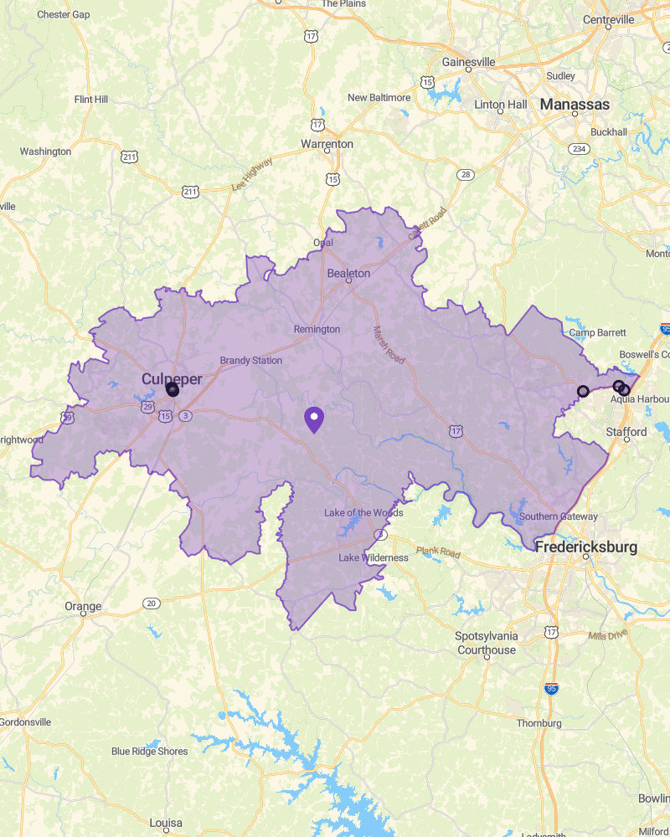
🔍 Catégorie(s) "PILATES STUDIO"

List of the 6 closest POI

 | Name | Address
1 | Studio 120 | 210 E Stevens St Suite 210, Culpeper, VA 22701, United States
2 | pranapiloga | 133 E Davis St #350, Culpeper, VA 22701, United States
3 | Culpeper Yoga Shala and Spa | 138 N Main St #101, Culpeper, VA 22701, United States
4 | Sol to Soul Yoga | 971 Garrisonville Rd, Stafford, VA 22554, United States
5 | Orangetheory Fitness | 308 Worth Ave, Stafford, VA 22556, United States
6 | Club Pilates | 1425 Stafford Market Pl, Stafford, VA 22556, United States

Blink Fitness: 0 in your area
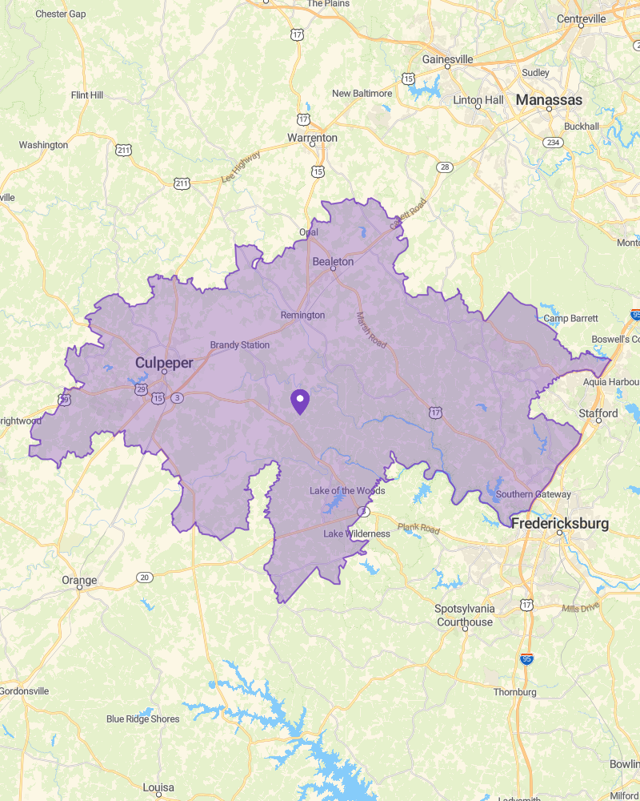
🔍 Dénomination contenant : "BLINK FITNESS"

List of the 0 closest POI

 | Name | Address

Data Sources


Analysis report made with Smappen



This report was carried out from the following databases:
- U.S. Census Bureau ACS 5-year (2024), LODES (2023), ZBP (2023)
- Smappen data

